# Homework: Computer Systems and Software – Trello

Problems for homework for the ["Software Technologies" course @ Software University.](https://softuni.bg/trainings/4383/software-technologies-january-2024)  
Submit this document as your homework.

## Travel Bucket List

**1.** Create a **new board named "Travel Bucket List"**. Do not use templates.

**2.** Add **a list for each continent** that you want to visit. /**Example:** Europe, Australia/

List Europe – cards – Paris, Italy, Fishing village in Portugal/.

**4.** Use **the label feature** to categorize the destinations by type (beach, adventure, culture, hobby etc.).

**5.** Use **the description feature** to add any must-see attractions and or activities.

6. Add **due dates** for each destination you want to visit in the next five years.

7. Delete the example photo, take a **screenshot of your board** and add it instead.

**Example:**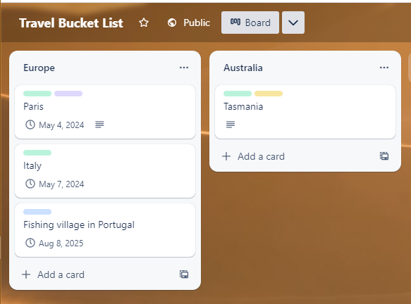

**8.** Delete the example photo, take a screenshot of **one of your cards,** and add it instead.

Example:  
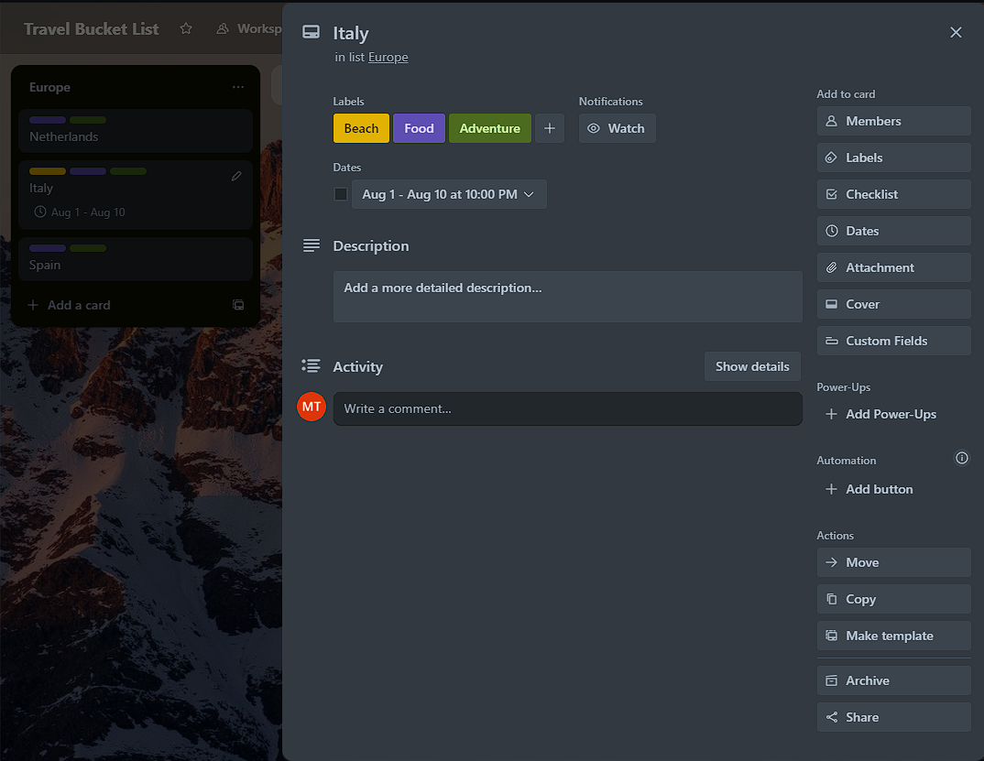

## Manage your Daily Tasks

Create a new board named "Daily To-Do List"

Add a list for each category of tasks (work, personal, school, etc.)

Add a "Today" list for your daily tasks

Add cards to each list with the tasks you need to complete

Use the label feature to categorize the tasks by priority (high, medium, low)

Use the due date feature to set deadlines for each task

Move tasks from the category lists to the "Today" list to focus on what needs to be done

Use Trello's mobile app to access your to-do list on the go and check off tasks as you complete them

Take a screenshot of your board with the lists that you created and add it here.

Take a screenshot of one of your cards that you already completed and add it here.

